CS 101 Lecture Notes
Prepared by Alper Özdamar & Fakih Karademir
Notes on Week 10 ( 04-06 April, 2007 )

FOR STATEMENT

n! = { 1 if n = 0 }
{ n * (n – 1) if n > 0 }

n! = 1 * 2 * 3 …. n

n > 0
int nfac = 1;
int i = 1;

while (i < = n)
{
nfac = i * nfac;
i++; → infinite loop example
}

int nfac,i;
for (nfac = 1, i = 2 ; i <= n; i++)

update
initiallization check
condition

nfac = i * nfac; statement

initialization

condition
statement
update
false
true

Find the even numbers from 1 to n( n > 1)
int i;
int sum = 0;

for ( i = 2 ; i < = n ; i = i + 2 )
sum = sum + i ;

while versiyon of upper statement :

int i = 2;
while ( i < = n)
{
sum = sum + i ;
i = i + 2;
}

another version of for:

int sum = 0;
int i = 2;
for ( ; i < = n )
{
sum = sum + i
i = i + 2;
}

public int findEvenSum(int n)
{
int sum = 0;
int i = 2;
while( i < = n )
{
sum = sum + i
}
return (sum);
}

main ()
{
int k =findEvenSum(12)
n = scan.nextInt();
k = findEvenSum(n);

*
***
*****
*******
int maxlines;
int line;
for (int line =1 ; line <= maxline ; line ++)
{
for (int i = maxline – line ; i >= 0; i-- )
System.out.print ( “ “);

for (int j= 1 ; j <= 2 * line - 1; i++ )
System.out.print ( “ *“);
System.out.print ( “ \n“);
}

Find the summation of input numbers. Perform the summation as long as the input number is [1,100] otherwise stop
int sum = 0;
int inputNo;
inputNo = scan.nexInt();

for ( sum = 0; input >= 1 && inputNo <= 100)
{
sum = sum + i;
System.out.print(“Enter an integer”);
inputNo = scan.nextInt();
}

Iterators: Iterator is an object that has methods that allow you to process a collection of items one at a time.
Scanner is an iterator
has Next()
has NextInt ()
has NextDouble()

www.google.com.tr www.google.com.tr dissect the file

java.sun.com/j2se/5.0 java.sun.com parse the file
j2se
5.0

import.java.util.Scanner;
import.java.io.* ;
public class URLDissector
{
String url;
Scanner fileScan, urlScan;
fileScan = new Scanner(new File(“url.inp”)),

// read and process each line of the file

statement
condition
false
true

while (fileScan.hasNext())
{
url = fileScan.nextLine();
System.out.println(“url = “ + url);
urlScan = new Scanner (url);
urlScan = new Delimiter (“/”);
//print each part of the url
while (urlscan.hasNext())
System.outprintln(“ “ + urlScan.next());
System.out.println() //print blank list
}

}

JAVA CONDITIONALS & LOOPS QUESTIONS

Question: Design and implement a Java program which prints a shape like a
diamond by using asterisk (‘ * ‘) characters. And the shape must have the size which user will enter at the beginning of the output.The user will determine the width of the diamond shape.

Sample Diamond Shape: *
***
*****
***
*

ANSWER:
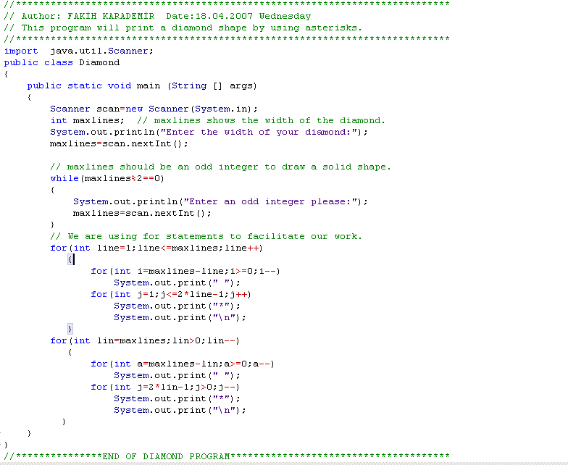

OUTPUT: 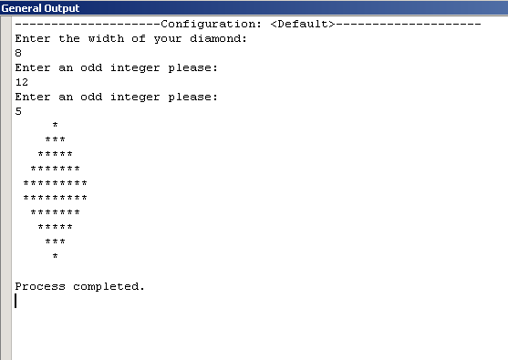

Question: When would we use a ‘for’ loop instead of a ‘while’ loop?
ANSWER: A ‘for’ loop is usually used when we know,or can calculate,
how many times we want to iterate through the loop body. A ‘while’
loop handles a more generic situation.
Question: What is an infinite loop? Specifically, what causes it?
ANSWER: An infinite loop is a repetition statement that never terminates.
Specifically, the body of the loop never causes the condition to become
false.

Question: Design and implement a program which computes the factorial
of a number given by the user.
ANSWER: 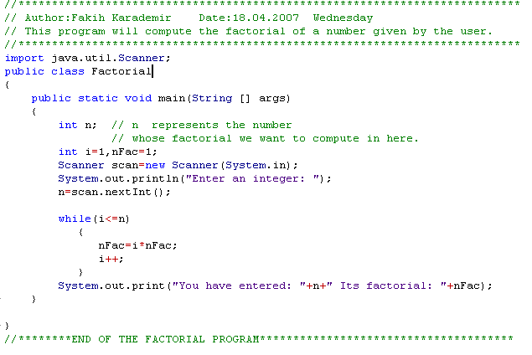
OUTPUT: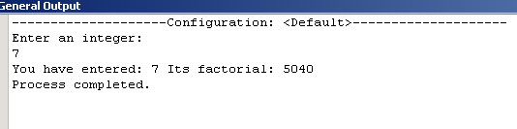
Question: Design and implement a Java program which prints a ‘x*x’
square by using loop statements and the print should consist of ‘#’
characters.
Sample Square Shape: # # #
# # #
# # #

ANSWER: 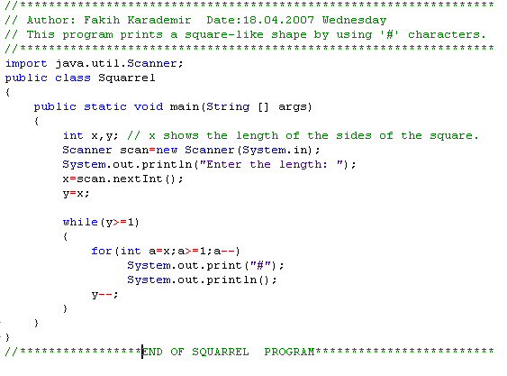
OUTPUT: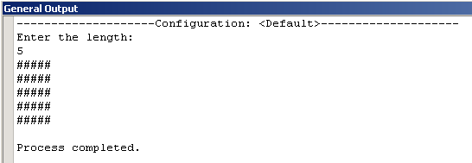

Question: Design and implement a Java program which prints a square-like shape with dimensions ‘x*x’ and x will be determined by the user.
Use ‘o’ characters to print this square with its gap inside.Don’t forget
about that inside of the square will not include characters.

Sample Square having a hole: o o o o
o o
o o
o o o o

ANSWER: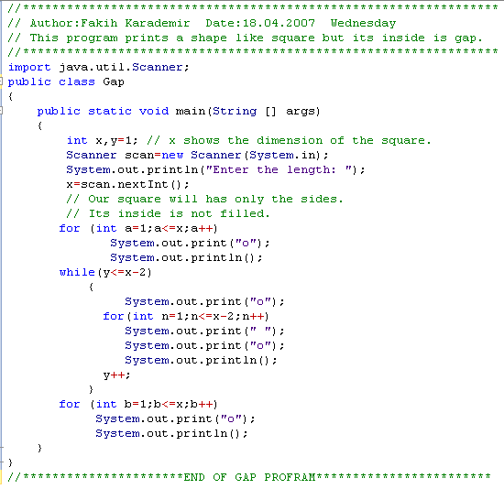
OUTPUT: 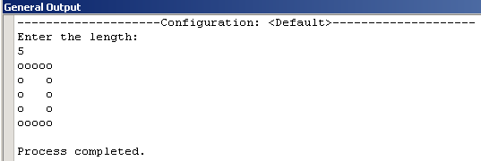

Question: Design and implement a Java program which computes the sum of any power of the numbers till a certain number. The bound number will
be determined by the user with Scanner class. I mean the program should be able to compute the sum of the squares of the numbers from one to one hundred or the sum of the cubes or the fourth powers of the numbers from one to twenty five and etc.
ANSWER:
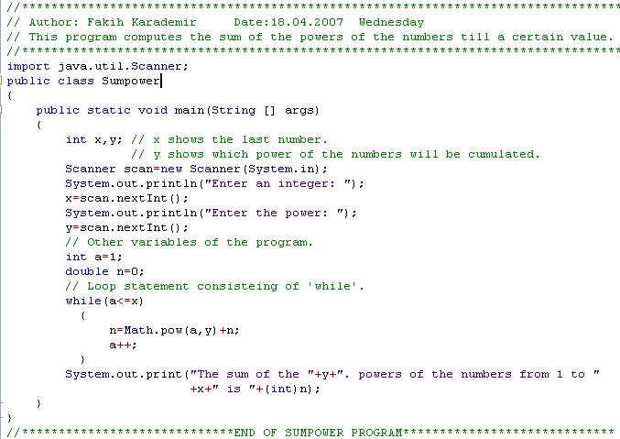


OUTPUTS OF SUMPOWER PROGRAM:
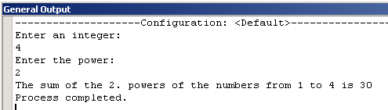

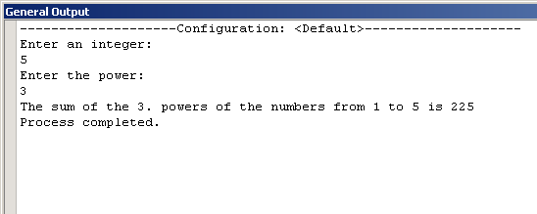

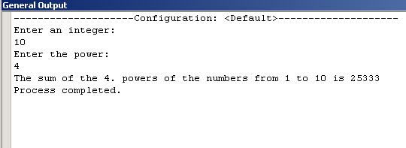

Question: By using ‘while’ loop design and implement a program which shows all the integers starting from 1 to any point determined by the user. The user will also determine the difference between consecutive numbers.You’ll try to write an arithmetic serie actually.
ANSWER: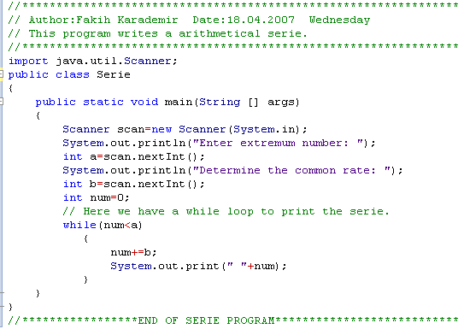
OUTPUT:
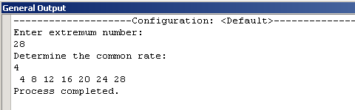

Question: Write a ‘for’ loop to print the odd numbers from 1 to 43
(inclusive). ANSWER:
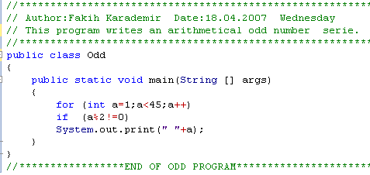
OUTPUT: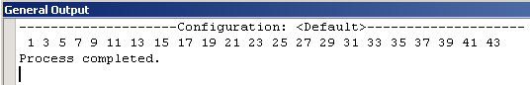

Question: Write a ‘while’ loop that verifies that the user enters a negative integer value.
ANSWER:
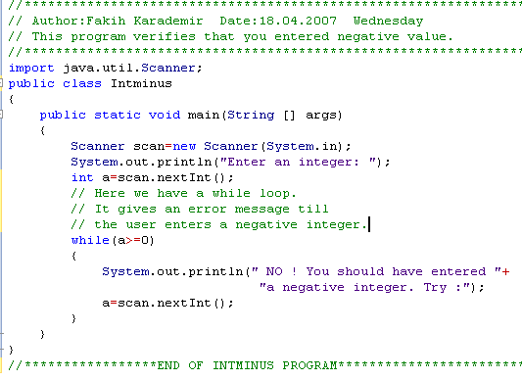
OUTPUT:
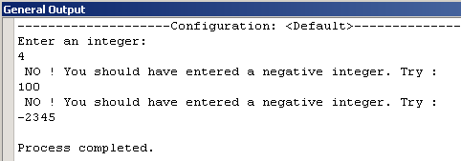

 END OF JAVA LOOP EXAMPLES

